CS 230 Module One Assignment: UML Class Diagram

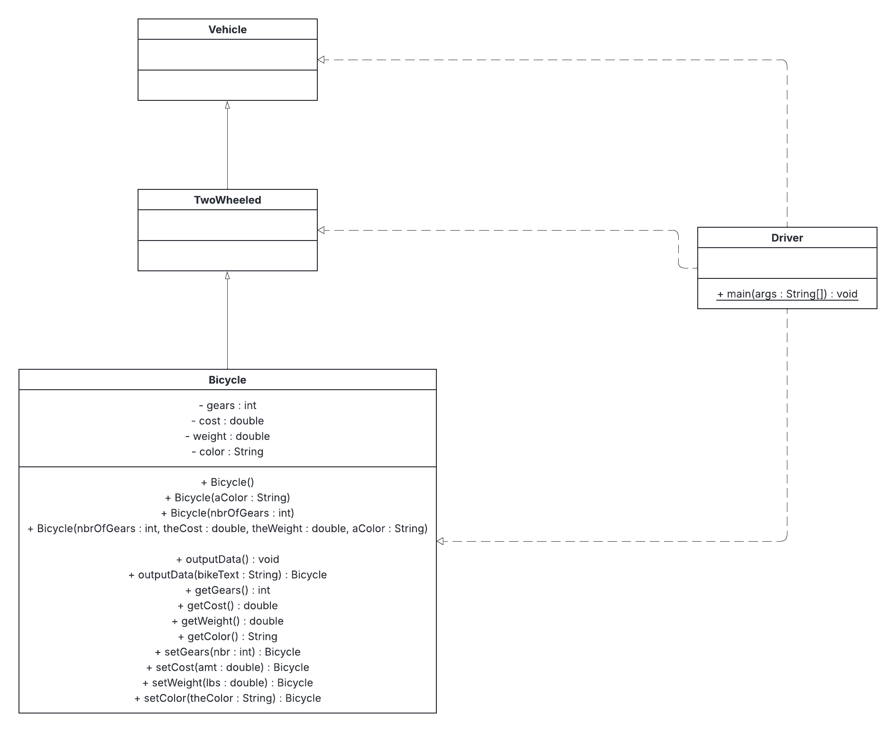

Object-Oriented Programming Principles
The UML class diagram demonstrates inheritance through the Vehicle, TwoWheeled, and Bicycle classes. Bicycle extends TwoWheeled, while TwoWheeled extends Vehicle. This creates an “is-a” relationship between the classes. In the diagram, inheritance is represented by solid lines with hollow triangle arrows pointing toward the parent class.
The Bicycle class also demonstrates encapsulation. Its gears, cost, weight, and color attributes are private, which prevents other classes from directly accessing the data. Instead, public getter and setter methods are used to retrieve or change those values. Encapsulation helps protect an object's data and provides controlled access to its attributes.
The Bicycle class also demonstrates polymorphism through method and constructor overloading. The class contains several Bicycle constructors that use different parameter lists, allowing Bicycle objects to be created in different ways. The outputData() method is also overloaded because one version takes no parameters while another accepts a String. Java determines which version to use based on the arguments provided.
AI Use Acknowledgment
I used ChatGPT to help clarify UML class diagram concepts, understand the relationships shown in the provided Java source code, and review my diagram and written explanations for accuracy. I also used Lucid AI within Lucidchart to assist with creating and formatting some of the UML relationships in the diagram. I reviewed the AI-generated suggestions and made the final decisions about the structure, content, and relationships shown in the diagram.

